**Perform facing operation on MS rod to calculate machining time and Material removal rate(MRR).**

**Apparatus:**

Lathe machine, stop watch, tachometer, MS rod.

**Figure:**

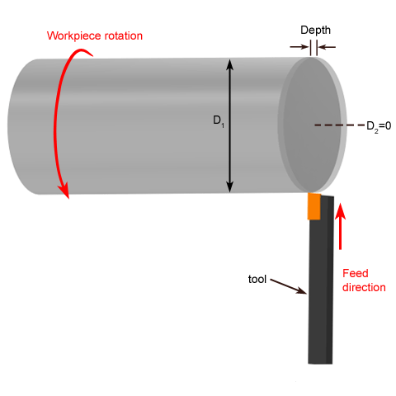

**Theory**

**Facing operation**

Facing is the process of removing metal from the end of a workpiece to produce a flat surface. Most often, the workpiece is cylindrical, but using a 4-jaw chuck you can face rectangular or odd-shaped work to form cubes and other non-cylindrical shapes.

**FORCE RELATIONSHIPS**

Several forces can be defined relative to the orthogonal cutting model. Based on these forces, shear stress, coefficient of friction, and certain other relationships can be defined. Consider the forces acting on the chip during orthogonal cutting in Figure .

The forces applied against the chip by the tool can be separated into two mutually perpendicular components: friction force and normal force to friction. The friction force F is the frictional force resisting the flow of the chip along the rake face of the tool. The normal force to friction is perpendicular to the friction force. These two components can be used to define the coefficient of friction between the tool and the chip



The friction force and its normal force can be added vectorially to form a resultant force R, which is oriented at an angle b, called the friction angle. The friction angle is related to the coefficient of friction as



In addition to the tool forces acting on the chip, there are two force components applied by the workpiece on the chip: shear force and normal force to shear. The sheer force Fs is the force that causes shear deformation to occur in the shear plane, and the normal force to shear Fn is perpendicular to the shear force. Based on the sheer force, we can define the shear stress that acts along the shear plane between the work and the chip:



where As= area of the shear plane. This shear plane area can be calculated as



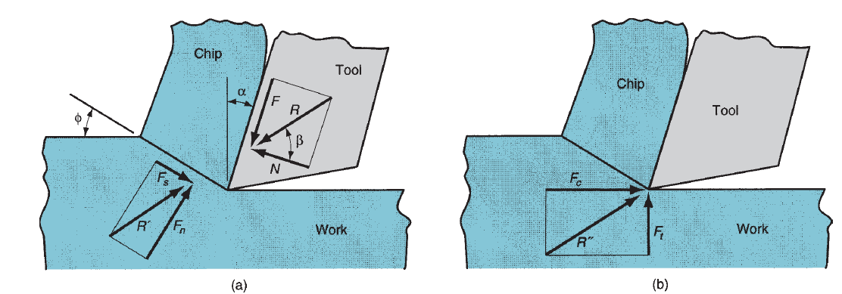

Fig: (a) Forces acting on the chip in orthogonal cutting (b) Forces acting on the tool that can be measured

**Cutting Parameters for Facing Operation**

**Cutting speed**

The rotational speed in turning is related to the desired cutting speed at the surface of the

Cylindrical workpiece by the equation

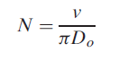

Where N =rotational speed, rev/min; v=cutting speed, m/min (ft/min); and Do=original diameter of the part, m (ft).

**Depth Of Cut**

The turning operation reduces the Length of the work from its original length Li to a final Length Lf, as determined by the depth of cut d.

d= $\frac{Li-Lf}{N}$

N= Number of passes

**Feed/Feed Rate**

The feed in facing is generally expressed in mm/rev (in/rev). This feed can be converted to a linear travel rate in mm/min (in/min) by the formula



where fr=feed rate, mm/min (in/min); and f =feed, mm/rev (in/rev)

**Machining Time**

The time to machine from one end of a cylindrical workpart to the other is given by

TM=xN

D=Diameter of workpiece

F=feed

N = Number of passes

**Procedure**

* Give a complete rotation to cross slide and note time
* Calculate feed rate and place workpiece in chuck
* Give 5 lines depth of cut to carriage and feed to cross slide
* Note time for actual machining

**Observations & Calculations:**

Number of passes=N=

Feed Rate=Fr=----------------- (mm\mint)

|  |  |  |  |  |  |  |  |  |  |  |
| --- | --- | --- | --- | --- | --- | --- | --- | --- | --- | --- |
| Sr. No | Diameter of rod  D | Initial Length of rod  Li | Final Length of rod  Lf | Depth of cut=t= $$\frac{Li-Lf}{N}$$ | RPMs | Cutting Speed  Vi= | Feed  F=Fr\RPM | Machining Time  TM=xN | Actual Machining time | MRR  =πxDxtxFr |
|  | mm | mm | mm | mm |  | mm\mint | mm\rev | mint | mint | mm\mint |
| 1 |  |  |  |  |  |  |  |  |  |  |
| 2 |  |  |  |  |  |  |  |  |  |  |
| 3 |  |  |  |  |  |  |  |  |  |  |

**Questions**

What is difference between rake angle and clearance angle?

_________________________________________________________________________________________________________________________________________________________________________________________________________________________________

Why rake angle is negative some time?

________________________________________________________________________________________________________________________________________________________________________________________________

What are different materials used for single point cutting tools?

________________________________________________________________________________________________________________________________________________________________________________________________

What is tool angle for facing operation?

______________________________________________________________________________________________________________________________________________________

**Comments on**

How to increase material removal rate?

________________________________________________________________________________________________________________________________________________________________________________________________________________________________________________________________

**Assignment**

Attach a graph between hardness and temperature of different cutting tools materials